OUTPUT:

1. CLUSTERING USING SINGLE LINKAGE

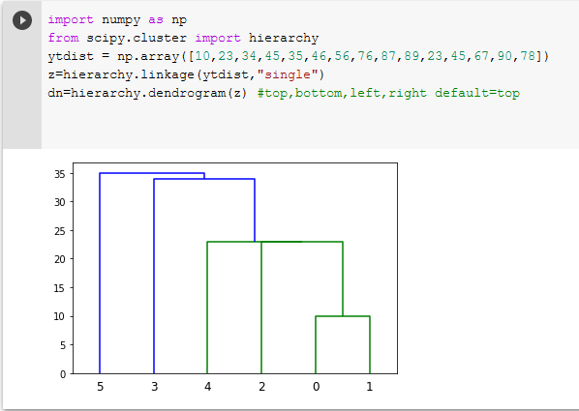

2.CLUSTERING USING COMPLETE LINKAGE

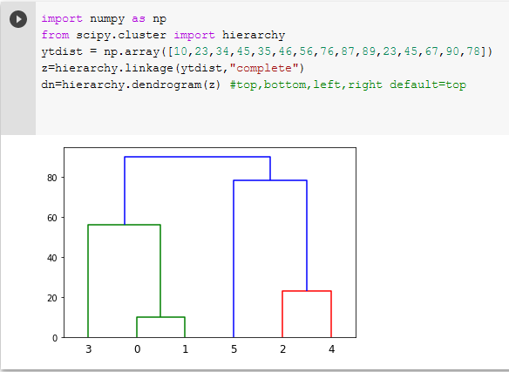

1. CLUSTERING USING AVERAGE LINKAGE

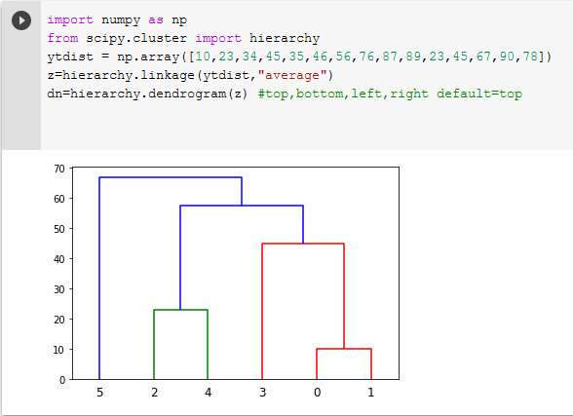

1.DBSCAN CLUSTERING ON IRIS DATASET

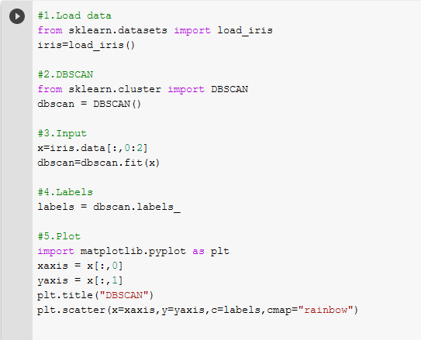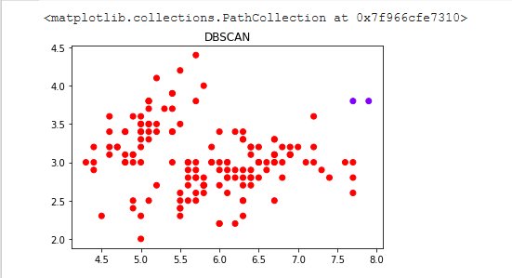

2.DBSCAN CLUSTERING ON MAKE_MOONS DATASET

